1. Show the output from the following fragments:

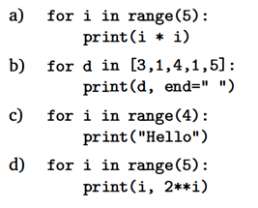

**a)**

0

1

4

9

16

**b)**

3 1 4 1 5

**c)**

Hello

Hello

Hello

Hello

**d)**

0 1

1 2

2 4

3 8

4 16

1. The Python print function supports other keyword parameters besides end. One of these other keyword parameters is sep. What do you think the sep parameter does? Hint: sep is short for separator. Show an example of using the sep parameter here.

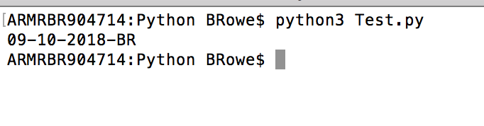

def main():

print('09','10','2018','BR', sep='-')

main()

1. What do you think will happen if the following code is executed?

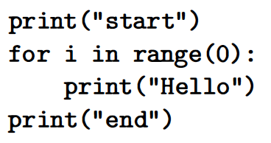

It will print the word start, then on a new line, the word end. The For loop is not executed.

1. Modify the future value program you write (see chapter 2 slides regarding the future value problem) so that the number of years for the investment is also a user input. Make sure to change the final message to reflect the correct number of years.

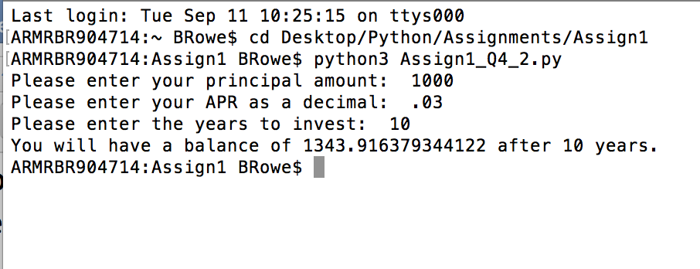

# Future Value Program

def main():

_principalAmt = eval(input("Please enter your principal amount: "))

_APR = eval(input("Please enter your APR as a decimal: "))

_investYears = eval(input("Please enter the years to invest: "))

for i in range(_investYears):

_interest = (_principalAmt * (1 + _APR))

_principalAmt = _interest

print("You will have a balance of",_principalAmt, "after", _investYears,"years.")

main()

1. Textbook Pg. 55, Programming exercises No. 12

def main():

for i in range(100):

x = eval(input("Please enter a mathematical expression: "))

print(x)

main()